巴中龙泉外国语学校初2016级期中考试
英语试题
考试时间：120分钟 总分：150分 命题人：赵俊
听力部分
(共20小题，满分25分)
第一节 听力选择（15小题，共15分）
根据你所听到的对话，选择正确的答案回答问题。
听下面5段对话，每听完一个对话后，做一个小题。
（ ）1. What do Chinese people usually do at the Spring Festival?
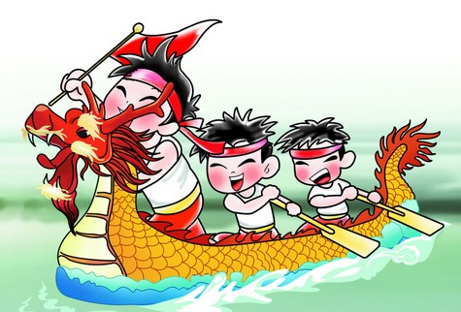
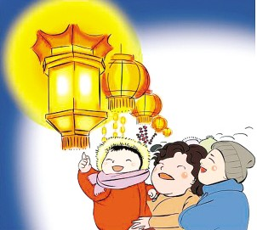
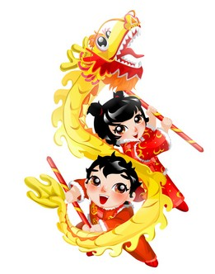

A. B. C.
（ ）2. What are they talking about?
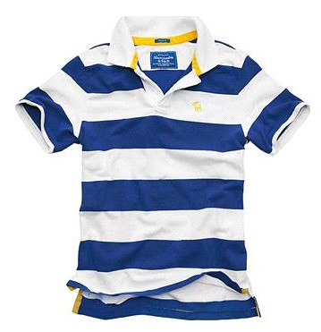
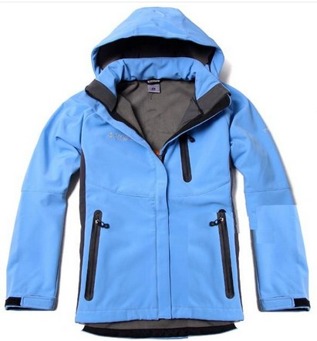
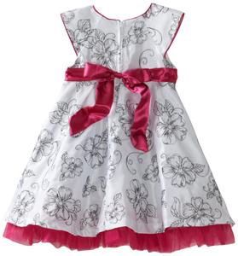

A. B. C.
（ ）3. What does the girl think of making word cards?
A. It’s boring B. It’s interesting. C. It’s difficult.
（ ）4. How often did the boy play tennis in the past ?
A. Once a week B. Twice a week. C. Twice a month.
（ ）5. When does the bookstore normally close?
A. At 6:30 p.m. B. At 7:30 p.m. C. At 8:30 p.m.
听第六段对话，做第6-7小题。
（ ）6. Where does the man want to go?
A. A bank. B. A restaurant. C. A park.
（ ）7. For whom does the man buy a dictionary?
A. His son. B. His daughter. C. His friend.
听第七段对话，做第8-9小题。
（ ）8. What does the man want to buy?
A. A blouse. B. A dress. C. A T-shirt.
（ ）9. What does it made of?
A. Silk. B. Fiber. C. Cotton.
听第八段对话，做第10-12小题。
（ ）10. What’s the relationship between the two speakers?3
A. Cousins. B. Classmates. C. Sister and brother.
（ ）11. What did Ann use to be like?
A. Short and outgoing. B. Short and quiet. C. Tall and quiet.
（ ）12. Where will Jack go ?
A.Paris. B. London. C. Ottawa.
听第九段对话，做第13-15小题。
（ ）13. Who has been to Hawaii before?
A. Julia. B. Julia’s mother. C. Mike.
（ ）14. How will Julia go to Hawaii?
A. By air. B. By subway. C. By train.
（ ）15. How long is Mike staying with his grandparents?
A. One week. B. Two weeks. C. One month.
第二节
根据你所听到的内容，选择正确的答案回答问题。（5小题，共10分）
（ ）16. Paper cutting started in China_______ years ago.
A. about 2,000 B. over 2,000 C. less than 2,000
( ) 17. Paper cutting is ______ strong national style and local features.
A. a piece of B. a symbol of C. a kind of
( ) 18. It was quite popular in ____ and many skills were developed at that time.
A. Ming Dynasty B. Qing Dynasty C. Han Dynasty
( ) 19. People usually used _______ to cut animals, flowers and figures with a pair of scissors or knives.
A. black paper B. red paper C. white paper
( ) 20. We can something from it, such as the comfortable environment and good harvests.
A. knew B. learn C. tell
笔试部分
一．单项选择（25分）
A. 选出与其意思相同或相似的短语 （5分）
( ) 21.You should do your best no matter what you do.
A. however B. whatever C. whenever
( )22. His parents take pride in everything good that he does.
A. be proud of B. are proud of C. are proud in
( )23. China is famous for tea.
A. is known for B. is known as C. is known to
( ) 24. Jack’s parents decided to send him to a boarding school.
A. make decisions B. made a decision C. make decision
( ) 25. Her grandparents came to take care of her.
A. look after B. look for C. look like
B. 从 A. B. C三个选项中选出最佳答案。（20分）
( )26. — do you improve your English?
—By listening to tapes and reading aloud.
A. How B. Why C. When
( )27. We speak _______ English _________.
A. every day; everyday B. everyday; every day
C. every day; every day
( )28. I like these photos and they can___me ___the life living in the countryside.
A. think; of B. remind; of C. wake; up
( )29. — Does my question sound ______enough?
—I don’t think so. You can ask more___ by using “could” instead of “can”.
A. politely; politely B. politely; polite C. polite; politely
( )30. History is an _____ subject, and I’m _______in it.
A. interesting; interested B. interested; interesting C. interesting; interesting
( )31. However, attention can also be a bad thing.
A. too much B. much too C. too many
( )32. Her son Coke, but now he milk.
A. used to drink； is used to drinking B. used to drinking； drinks
C. is used to drink；is drinking
( ) 33. It took Janet three hours reading this interesting story.
A. to finish B. finished C. finishing
( ) 34. Both your brother and your sister listening to music.
A. are B. is C. am
( ) 35. I bought two pens. One is black, is red.
A. other B. another C. the other
( ) 36. My mother spent two hours the housework yesterday.
A. to do B. do C. doing
( ) 37. Many kites are______ paper and bamboo.
A. made of B. made from C. made in
( ) 38. Do you enjoy __________ on the Internet?
A. surfing B. surf C. to surf
( ) 39. She said she had some trouble ___________ her homework.
A. finish B. finishing C. to finish
( ) 40. My father gave up ________ at last.
A. smoke B. smoking C. to smoke
( ) 41. Not only you but also I ______wrong.
A. are B. is C. am
( ) 42.If you don’t know how to pronounce new words,___in a dictionary,please.
A. look it up B. look them up C. look up them
( )43. Look! ______happily the children are playing over there!
A. How B. What C. How a
( ) 44.Sometimes I find it hard ______ English well.
A. to study B. studying C. study
( ) 45. I didn’t understand __________ , so I raised my hand to ask him.
A. what my teacher says B. what did my teacher say
C. what my teacher said
二．完形填空 （共15小题，满分15分）
A
According to Chinese history, sky lanterns were first used 46 Zhuge Kongming. He sent them out to 47 help when in trouble. Today, sky lanterns are used at festivals and other celebrations. They are made of bamboo and 48 paper. When the lanterns are 49 , they slowly rise into the air like small hot-air balloons for all to see. They are seen as bright symbols of 50 and good wishes.
( ) 46. A. by B. for C. with
( ) 47. A. ask B. ask for C. ask about
( ) 48. A. covered B. cover with C. covered with
( ) 49. A. lit B. light C. lighting
( ) 50. A. happy B. happiness C. happily
B
Here are some important rules for you to become a good student at school.
◆ Go to school on time
As a 51 , going to school on time is very important. If you are late, you will not start your lesson at the same time with your classmates so that you will 52 some lessons, which can influence your grades. If you are late, the teacher will be 53 with you, too. So remember to go to school on time.
◆Follow the school rules
Do not 54 the school rules. For example, you are not allowed to chew gum or sleep in class. Don’t fight 55 your classmates, and you should be friendly to your classmates and your teachers be ready to 56 others who are in trouble. You mustn’t run in the hallway.
◆Prepare lessons before class
57 you want to know what you will learn next day, you’d better prepare lessons. It is good for your study and it can help you get good 58 . Besides, you should listen to the teachers as 59 as possible.
◆ Take part in all kinds of activities at school
Try to be in all kinds of activities at school. For example, sports can not only improve the relationship between you and your classmates but also make you 60 . It’s easy to follow the school rules and you will become a good student.
( )51. A. classmate B. teacher C. student
( )52. A. miss B. teach C. study
( )53. A. pleased B. angry C. strict
( )54. A. break B. make C. change
( )55. A. to B. at C. with
( )56. A. help B. love C. understand
( )57. A. If B. Although C. Unless
( )58. A. lessons B. studies C. grades
( )59. A. happily B. carefully C. easily
( )60. A. calmer B. funnier C. healthier
三、 阅读理解 (20小题，每小题2分，共40分)
阅读下面4篇语言材料，然后按文后要求做题。
A
Are you looking for something fun and would you like to help others in your spare time? Then join us to be a volunteer! We’re a non-profit (非赢利的) organization. We have volunteer jobs of all ages, anyone, from twelve-year-old children to people in their seventies can become a volunteer.
You can help people in many ways. Schools need help with taking care of children while parents are working. Hospitals need volunteers to look after children while their parents are seeing a doctor. Animal lovers can help take care of those dogs and cats without home. There is something for everyone.
“As a volunteer, I don’t want to get anything. Seeing the children’s happy faces, I’m happy, too.” Said Carlos Domingo, an old woman of 62. “I often played computer games in my spare time before. Now I help older people learn how to use computers.” Said another volunteer at the age of 18.
If everyone helps out a bit, we’ll have a better world to live in. Interested? Call us 0916--4462437 or visit our website: www.rczx.com
( )61. When do the volunteers help others?
A. In their spare time B. At weekends C. On weekdays.
( )62. __________ can be a volunteer.
A. Children B. Old people C. Anyone aged 12—70
( )63. Volunteers want to get ___________when they help others.
A. money B. computers C. nothing
( ) 64. Carlos Domingo does volunteer work with ____________
A. animals B. computers C. older people
( )65. The passage may come from ___________
A. a newspaper B. a story-book C. a picture book
B
Pets are a part of people’s lives. Some pets are like family. In these days, many people have pets at home and spend a lot of money improving their lives. In fact, in some parts of the world, pets get real VIP treatment(待遇). VIP usually means Very Important People, but here VIP means Very Important Pets!
When you want to give Fido or Kitty a holiday, or when you are going away on business, you can exercise inside or outside, and cats have a large place with something to climb on and play with. The guests get the best food during their stays at these hotels.
There are other special services at these hotels. Imagine you are traveling and you want to see your pet: the hotel can put a video camera in the pet’s room. So you can see your Fido or Kitty on TV.
The hotels usually have good groomers(美容师): They often bath and take the best hair care for the pets. But you need to make an appointment(预约) because people are usually very busy taking care of pets.
( )66. The new meaning of “VIP” in this passage is _________.
A.Very Important People. B.Very Important Pets! C.Very Important Plants!
( )67. Where can you put your pet when you are away on business?
A. Other friends’ houses B. The pets’ home C. The special hotels
( )68. What does “Fido” stand for(代表) here?
A. A kind of pets B. people’s name C. a place
( )69. How can you see your pet during your traveling?
A. See their photos B. On TV C. On computers
( )70. You need to make an appointment when you want a good groomer for your pet because __________.
A. They often have vacations. B. They like to take care of people.
C. They are usually very busy taking care of pets.
C
Two farmers were on their way home one evening after a hard day's work．Both were tired．They happened to look up at the sky and saw a black cloud overhead．
"Ah!" said one farmer, "tomorrow we shall have rain and the rice will grow well．" The second answered, "Nonsense （胡说）, the rain will only kill the crops （庄稼）．"
So they began to fight．Just then a third farmer came along and asked them why they were quarreling（争吵）．Both farmers explained about the black cloud．
"What cloud?" asked the third farmer．They all looked at the sky．The cloud was no longer there．
( )71.The two farmers were _____．
A．going home B. going to the field C．going to work
( )72.The two farmers _____ on that day．
A．had a holiday B．worked hard C．wanted to fight with each other
( )73.According to the passage, when there are black clouds in the sky, the two farmers think _____．
A．it will rain soon B．it will be fine C．it will get hot
( )74.The two farmers fought because _____．
A．they were hungry B．it rained
C．one said the rain would do good to the crops and the other didn't think so
( )75.The third farmer came and said to the other two．He _____．
A．wanted to make friends with them B．joined them in the quarrel
C．wanted to know why they were fighting
D
Dave was a college student. His uncle was very rich, but he had no child of his own. Soon after Dave left college, his uncle died. He left Dave a lot of money, so Dave decided to set up his own company.
He found a nice office, bought some new desks and chairs and moved in. He had only been there for a few hours when he heard someone coming towards his house.
"It's my first customer (顾客)!" he thought. He quickly picked up the telephone and pretended (假装) to be very busy answering an important call from someone in New York. The caller wanted to buy a big and expensive house in the country.
The man knocked at the door while this was going on, and he came in and waited politely for Dave to finish his conversation. Then he said to him, "I'm from the telephone company, and I was sent to fix (修理) your telephone."
( )76. Dave could set up a company of his own because __________.
A. he got a lot of money B. he had borrowed a lot of money
C. His father left him a lot of money
( )77. Dave had been there for __________ when the man from the telephone company came.
A. almost a week B. two days C. a few hours
( )78. Why did Dave pick up his telephone when he heard someone coming?
A. Because someone called him from New York.
B. Because he wanted to let him know he was busy with his business.
C. Because his uncle telephoned him at that time.
( )79. What did Dave's company sell?
A. Color TV sets. B. Houses. C. Clothes.
( )80. Could Dave get a telephone call from New York before the man from the telephone company came?
A. No, he couldn't. B. Of course, he could. C. We don't know.
四．情景交际（共10分）
A
A: You look unhappy. 81
B: I failed in the English exam.
A. How can you get such a high score?
B. I’m sorry to hear that.
C. What happened to you?
D. That’s great.
E. What about you?
A: 82 How many scores did you get?
B: Just 50. 83
A: I got a pretty high score 96.
B: Wow! 84
A: You know, I take a lot of notes in class and practice reading every morning. I can help you with your English if you like.
B: 85 Thank you. But I’m still worrying about how to pass it next time.
A: Though your English is poor, you really do a good job in physics.
B: Yes, I really hope I can be excellent in every subject.
81.___________.82.____________.83____________84.____________85._________
B
A: How long have you been a reporter?
B： 86
A：Then what did you do five years ago?
B： 87 . I worked as a teacher for ten years.
A: Oh, what did you use to do when you were free as a teacher?
B: 88 . Sometimes I played with my students .It was wonderful.
A: Did you use to surf the Internet?
B: No, I didn’t .We didn’t have computers in our school then. But teachers and students in our school can surf the Internet now. 89 .
A: Then why did you become a reporter later? You didn’t like teaching?
B: That was not because I didn’t like teaching. 90 .I do quite well as a reporter.
A. I used to be a teacher , a history teacher.
B. I found I could do reporting work better than teaching work
C. I often chat with some of my workmates in the school.
D. I used to play basketball.
E. For about five years.

86.___________.87.____________.88____________89.____________90._________
五．句型转换。（每空1分，共10分）
91. The man was too sad to say a word. (改为同义句)
The man was ________ sad ________he couldn’t say a word.
92. Jack is afraid of giving a speech in public. (改为同义句)
Jack is afraid _______ _______ a speech in public.
93. Paula used to be really quiet. (改为否定句)
Paula ________ _______ to be really quiet.
94. People grow tea in Hangzhou. (改为被动语态)
Tea _________ _________by people in Hangzhou.
95. It seemed that the man lost his wallet.(改为同义句)
The man _______ ______lose his wallet.
六．短文改错。（共10分）
Li Wen is a normal 15-years-old boy from the countryside. 96.________
He works very hardly and does well in school. It is hard 97.________
believe that he used to have difficulties in school. When 98.________
he was a little boy, he seldom caused any problem, 99._________
However, things began to changed a few years ago. 100.________
His parents moved to the city to look at jobs, and his 101.________
grandparents came to take care of he. But he missed his 102._________
parents so much and he often felt alone and unhappy. 103._________
Li Wen’s unhappy began to influence his schoolwork. 104._________
So it’s very important to parents to be there for their children. 105._________
七、书面表达（15分）
以下是你的好朋友Jack在外貌、性格和爱好方面的变化。请你根据表格内容介绍他的变化并谈谈你对他的变化的看法。写一篇不少于70词的短文。
 | In the past | Now
Appearance | thin, short | tall, strong, wear glasses
Personality | quiet | outgoing
Hobbies | watch TV | play basketball, read books
My friend Jack has changed a lot in the last few years._______________________
__________________________________________________________________
__________________________________________________________________

答题卡
四．情景交际 （10分）
81.___________.82.____________.83____________84.____________85._________
86.___________.87.____________.88____________89.____________90._________
五. 句型转换。(每空一词，每空1分，共10分)
91. ___________ ____________ 92. ___________ ____________
93. ___________ ____________ 94. ___________ ____________
95. ___________ ____________
六．短文改错。（共10分）
96. __________ 97._________ 98. _________ 99.___________ 100. ___________
101._________ 102._________ 103. _________ 104.__________ 105. ___________
七．书面表达（15）
My friend Jack has changed a lot in the last few years. _________________________

_____________________________________________________________________

_____________________________________________________________________

_____________________________________________________________________

_____________________________________________________________________

_____________________________________________________________________

_____________________________________________________________________

_____________________________________________________________________

_____________________________________________________________________

